Pembroke Minor Hockey Association

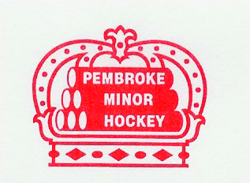

2022/2023 House League Tournament Application Form

**Team Name:** _________________________________________________________________________________________________

**Association:** ______________________________________________________________________________________________

**Address:** ___________________________________________________________________________________________________

**City/Town:** _________________________________________________________________________________________________

**Postal Code:** ________________________________________________________________________________________________

**Home Colours:** ______________________________________________________________________________________________

**Away Colours:** ______________________________________________________________________________________________

**Name Phone # E-Mail**

**Manager** ___________________________ ______________________ __________________________

**Coach** ___________________________ ______________________ __________________________

**Signature of Coach or Manager:** ____________________________________ **Date:** ____________________________

**Select Tournament:**

* **U7 IP Fun Day January 7, 2023 $275.00**
* **U9 House League January 14-15, 2023 $550.00**
* **U11 House League January 21-22, 2023 $850.00**
* **U13 House League November 5-6, 2022 $850.00**
* **U15 House League December 10-11, 2022 $850.00**
* **U18 House League October 29-30, 2022 $850.00**

To avoid disappointment, please forward this application along with your team roster to [coachboomerpmha@gmail.com](mailto:coachboomerpmha@gmail.com) as soon as possible.

Tournament registration fees may be paid via E-transfer to [treasurer@pembrokeminorhockey.com](mailto:treasurer@pembrokeminorhockey.com). Kindly indicate team name/association/division in the memo field. If paying by cheque, please include the same information and forward payment to:

Pembroke Minor Hockey Association

C/O Tournament Director

PO Box 725

Pembroke, Ontario

K8A 6X9